עבודת בית 8 – קבצים.

## שאלה 1 (קוד):

#include <stdio.h>

#include <stdlib.h>

#include <string.h>

int main(int argc, char* argv[]) {

if (argc != 2) {printf("incorrect arguments!"); exit(EXIT_FAILURE);}

char c;

int counter = 0;

FILE* toPrint;

toPrint = fopen(argv[1],"rt");

while((c = fgetc(toPrint)) != EOF) {

if (c == '\n') ++counter;

printf("%c",c);

if (counter == 10) {

counter = 0;

system("pause"); // windows only

}

}

fclose(toPrint);

system("pause");// windows only.

exit(EXIT_SUCCESS);

}

## שאלה 1(פלט):

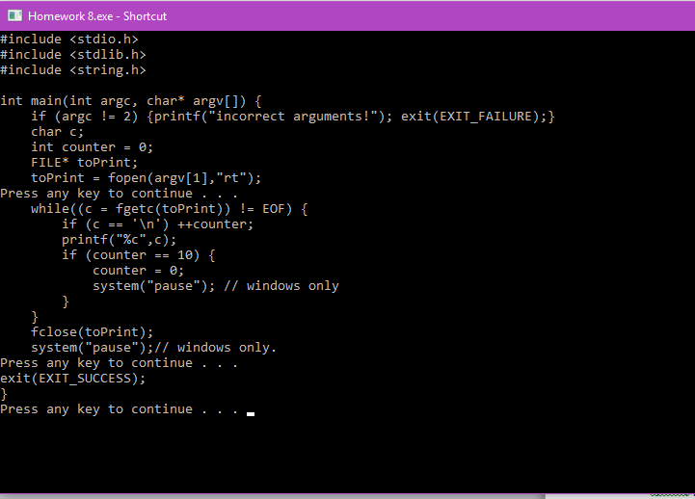

## שאלה 2(קוד):

#include <stdio.h>

#include <stdlib.h>

#include <string.h>

#include <stdbool.h>

int main(int argc, char* argv[]) {

if (argc != 2) {printf("incorrect arguments!"); exit(EXIT_FAILURE);}

int countLeft = 0, countRight = 0, generalCount = 0;

bool isBalanced = true;

char c;

FILE* checkFile = fopen(argv[1],"rt");

if (!checkFile) { printf("file read error!"); exit(EXIT_FAILURE); }

while ( (c = fgetc(checkFile)) != EOF ) {

if (c == '{') { ++countLeft; ++generalCount; }

if (c == '}') { ++countRight; --generalCount; }

if (generalCount < 0) isBalanced = false;

}

if (countLeft == countRight) {

printf("number of '{' characters in argument EQUALS number of '}'");

if (isBalanced == true) printf(" and is balanced\n");

else printf(" BUT is not a balanced series of parentheses\n");

}

else

printf("number of '{' characters does NOT EQUAL number of '}'\n");

if ( (fclose(checkFile)) == EOF ) {

printf("file close error!");

exit(EXIT_FAILURE);

}

system("pause");

exit(EXIT_SUCCESS);

}

## שאלה 2(פלט):

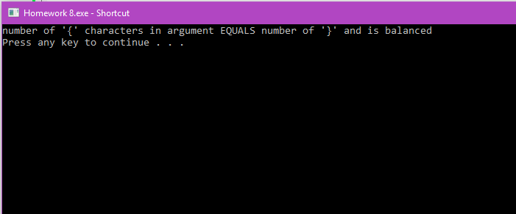

## שאלה 3(קוד):

#include <stdio.h>

#include <stdlib.h>

#include <string.h>

#include <stdbool.h>

int main(int argc, char* argv[]) {

if (argc != 4) {printf("incorrect arguments!"); exit(EXIT_FAILURE);}

//initializers

FILE* file1 = NULL, *file2 = NULL,*target = NULL;

char c1 = '\0', c2 = '\0';

file1 = fopen(argv[1],"rt"); file2 = fopen(argv[2],"rt"); target = fopen(argv[3],"wt");

//read write success check

if (!file1 || !file2 || !target)

{ printf("file read error!"); exit(EXIT_FAILURE); }

// check if file1 is empty

fseek(file1, 0, SEEK_END);

if (ftell(file1) == 0) c1 = EOF;

else rewind(file1);

//check if file2 is empty

fseek(file2, 0, SEEK_END);

if (ftell(file2) == 0) c2 = EOF;

else rewind(file2);

//while file1 AND file2 are both full

while (c1 != EOF && c2 != EOF) {

while ( (c1 = fgetc(file1)) != '\n' ) {

if (c1 == EOF) break;

fputc(c1,target);

}

fputc('\n',target);

while ( (c2 = fgetc(file2)) != '\n' ) {

if (c2 == EOF) break;

fputc(c2,target);

}

fputc('\n',target);

}

// if file1 is not empty

if (c1 != EOF) {

while ( (c1 = fgetc(file1)) != EOF ) {

fputc(c1,target);

}

}

//if file2 is not empty

if (c2 != EOF) {

while ( (c2 = fgetc(file2)) != EOF ) {

fputc(c2,target);

}

}

system("pause");

exit(EXIT_SUCCESS);

}

## שאלה 3(פלט): תמונה ראשונה (קובץ קלט ראשון לא ממוזג)

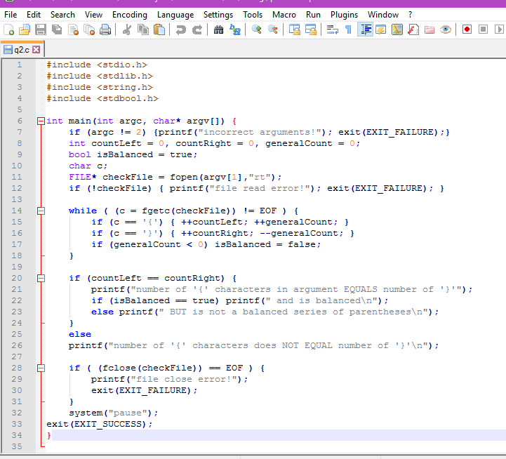

## תמונה שניה (קובץ קלט שני לא ממזוג):

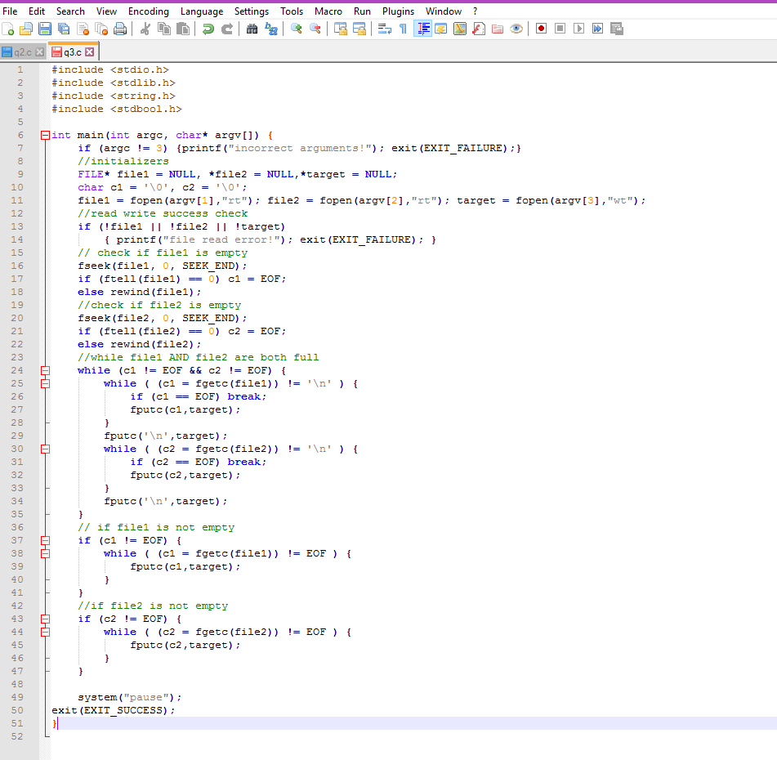

## תמונה שלישית (קובץ ממוזג):

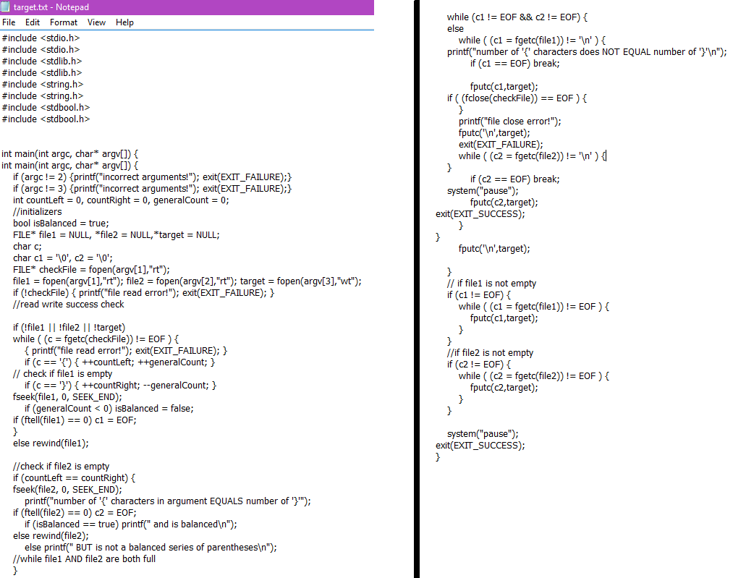

## שאלה 4(קוד):

#include <stdio.h>

#include <stdlib.h>

#include <string.h>

#define MAX_PATH 260

int main() {

char fName1[MAX_PATH]; char fName2[MAX_PATH];

printf("Enter file name 1:"); scanf("%s",fName1);

printf("\nEnter file name 2:"); scanf("%s",fName2);

//initializers

FILE* file1 = NULL, *file2 = NULL;

char c1 = '\0', c2 = '\0';

file1 = fopen(fName1,"rt"); file2 = fopen(fName2,"rt");

//read write success check

if (!file1 || !file2)

{printf("\nfile read error!"); exit(EXIT_FAILURE); }

//while simultaneous reads are equal and end of files not reached.

while (c1 != EOF && c2 != EOF ) {

c1 = fgetc(file1);

c2 = fgetc(file2);

if (c1 != c2) {

printf("\nfiles contents are different. ");

system("pause");

exit(EXIT_SUCCESS);

}

}

printf("\nfiles are identical. ");

system("pause");

exit(EXIT_SUCCESS);

}

## שאלה 4(פלט): (בחרתי את אותו הקובץ בשמות שונים(

